Lab 6 – Logical and Conditional Statements, 99 Bottles of Beer

# Purpose

* 99 Bottles of Beer
* Name Form
* Upload your website to a Web server

# Due Date

* This lab must be handed in:

**Friday March 01, 2019 – before midnight**

# Assessment

* This Lab is worth 2% of your total course mark.

# Assigned Readings

The following chapters of **Fundamentals of Web Development** will be useful in completing this exercise:

* Chapter 4
* Chapter 8

# Lab Supplies

To complete this lab you will require the following lab supplies:

* Textbook: **Fundamentals of Web Development** by Randy Connolly and Ricardo Hoar
* EasyPHP, or other WAMP server
* Eclipse, Notepad (or other text editor, or IDE)
* FileZilla (or other FTP client)

# Summary of Tasks

1. Develop the logic to display the song 99 Bottles of Beer
2. Develop the logic to implement NameForm.
3. Upload your website to the webserver
4. View your webpage using a web browser
5. Submit Lab Link on Brightspace
6. Submit source code of all PHP files on Brightspace

# Task 1

Before getting started with the following tasks, review the ‘Common Look and Feel’ video provided on Brightspace (under: Course Content 🡪 Extra Materials). Using the knowledge gained in these materials, implement the following Design Pattern to create a ‘Common Look and Feel’ to be used on every page of your website.

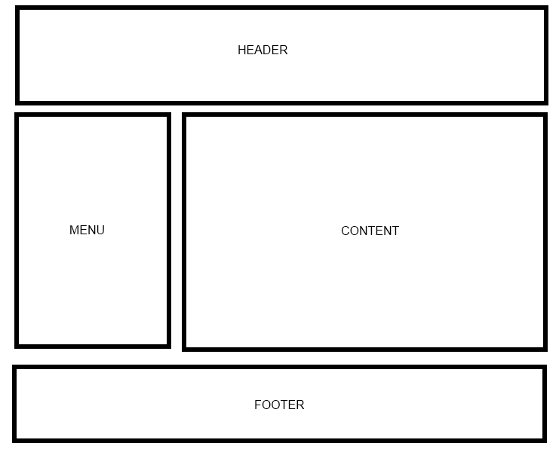

Your web site will include the following PHP scripts:

* Header.php
* Footer.php
* Menu.php
* All.php
* EvenOdd.php
* NameForm.php

**Header.php**

Header.php must contain a script to display a Common Header that will appear on every page. The header must contain a banner (images, css, etc).

**Footer.php**

Footer.php must contain a script to display a Common Footer that will appear on every page. The footer must contain Student Number, First Name, Last Name, Email Address

**Menu.php**

Menu.php must contain a script to display a Common Menu to be shown on every page. The menu must contain links to All.php, EvenOdd.php, and NameForm.php

**All.php**

In All.php, you need to create a script that will display the lyrics to the song 99 Bottles of beer. To do this you must use the **Logical and Conditional statements** of PHP. Also use the PHP statement ‘include’ to add your Header, Menu and Footer to the page.

99 Bottles of Beer example:

99 bottles of beer on the wall...  
You take one down you pass it around ...  
98 bottles of beer on the wall.  
  
98 bottles of beer on the wall...  
You take one down you pass it around ...  
97 bottles of beer on the wall.

. . . .

…….

1 bottles of beer on the wall...  
You take one down you pass it around ...  
0 bottles of beer on the wall.  
  
There are no more bottles of beer.

**EvenOdd.php**

In EvenOdd.php, you need to create a script that will display modified lyrics to the song 99 Bottles of beer. You must implement it using the **Logical and Conditional statements** of PHP. Also use the PHP statement ‘include’ to add your Header, Menu and Footer to the page.

99 Bottles of Beer example:

99 bottles of beer can serve odd number of guests

98 bottles of beer can serve even number of guests  
97 bottles of beer can serve odd number of guests  
96 bottles of beer can serve even number of guests  
………

……….

3 bottles of beer can serve odd number of guests

2 bottles of beer can serve even number of guests  
1 bottle of beer can serve ONLY ONE guest

**NameForm.php**

In NameForm.php, first you need to design a HTML form as below:

|  |
| --- |
|  |

Then you need to write a PHP script such that clicking ‘Submit’ button will display a message based on the name(s) provided by the user and current time of the day (in 24-hour format).

If the current time is less than 12 (i.e. it is between 00:00 - 11:59), then you have to display the message “Good morning”; otherwise you have to display “Good day”.

You must implement it using the **Logical and Conditional** statements of PHP in the following ways:

* + If all three names are missing display the following error message, "You did not supply any names".

Sample output is as follows:

|  |
| --- |
|  |

* + If only the first name is provided and the current time is less than 12, display the following message, "Good morning xxxx! You did not provide middle and last name."

If only the first name is provided and the current time is greater than or equal to 12, display the following message, "Good day xxxx! You did not provide middle and last name."

* + If the first name as well as the last name is provided and the current time is less than 12, display the following message, "Good morning xxx xxx! You did not provide middle name".

If the first name as well as the last name is provided and the current time is greater than or equal to 12, display the following message, "Good day xxx xxx! You did not provide middle name"

* + If all three names are provided and the current time is less than 12, display the following message, "Good morning xxx xxx xxx! Your middle name is very unique."

If all three names are provided and the current time is greater than or equal to 12, display the following message, "Good day xxx xxx xxx! Your middle name is very unique."

* + If any other combination is supplied and the current time is less than 12, display the following message, "Good morning, Welcome to the World of PHP”.

If any other combination is supplied and the current time is greater than or equal to 12, display the following message, "Good day, Welcome to the World of PHP”.

# Note: Please make sure that the header, footer, and menu are distinguishable with respect to the body (main content) of the web page.

# Task 2

Upload your website to the Web server. Use an FTP client to connect to your Web server.

Once you connect to the webserver using an FTP client, create a directory called ‘/CST8238/Lab6’. Once your course directory has been created navigate to that new directory. Add your index.php file to this location. (Using FileZilla simply drag the index.php file into your folder). The index.php file will refer to all of your php files.

# Task 3

View your website using a web browser. Open a web browser and navigate to the following web address:

**http://web-server_domain_name/CST8238/Lab6/<filename>**

For example, the web address to my page is:   
  
http://profrejaul.com/CST8238/Lab6/index.php

Where ‘profrejaul.com’ is the domain name of the Web server, ‘ /CST8238/Lab6’ is the name of the directory I created in the Web server using FTP client and ‘index.php’ is the main web page I created for this lab.

# Task 4

Once you have confirmed that your webpage is available online, you are ready to hand in your lab.

Create a compressed file (Lab6.zip) which will contain the following PHP files:

* Header.php
* Footer.php
* Menu.php
* All.php
* EvenOdd.php
* NameForm.php

Create a word document (Lab6.doc) in which write the following Information:

* Student Number
* First Name
* Last Name
* The URL, or hyperlink of the home page (All.php) of Lab 6, prepared in Task 3

To hand in your lab go to Brightspace and navigate to *Course Content 🡪 Labs* and click on

‘*Lab 6 - Logical and Conditional Statements, 99 Bottles of Beer*’ link.

Upload the word document (**Lab6.doc**) and the compressed file **(Lab6.zip**) on Brightspace.

Finally, click the ‘Submit’ button to send the lab to your professor.

**IMPORTANT NOTE**: If the URL, or hyperlink, does not direct the professor to the lab you will receive a ZERO for the lab assignment.

**IMPORTANT NOTE:** You may only submit a Lab ONE TIME. Be sure the lab is complete before clicking on the ‘Submit’ button.